Our Services

**Applying process to creativity in building websites**

Building a website and additions with us is a collaborative process that is tailored to your needs. We spend time at the beginning to assess your needs, understand your environment and develop a plan.

This is a process we call The Juicy Loop

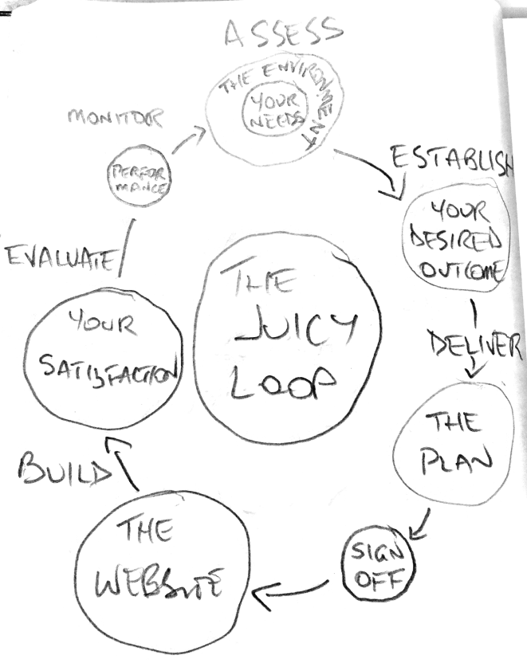

1. Assess

We collaborate with you to get the big picture of what you’re up against and what you deliver to the world. We look at your customers and how they should best experience your site. We get a sense of how you roll so we can transfer your DNA into your ride. And we refine what you need so you don’t waste time and money.

2. Establish

Our process includes a deep dive into your desired outcomes including features & functionality and how to measure the success of your project, based on your budget.

3. Deliver

We build a creative blueprint of the website including wireframes and mood boards so that you have peace of mind in signing off.

4. Build

We build your website, focussing on functionality, user experience and ease of maintenance so that you can keep it fresh and juicy going forward.

5. Monitor

Getting your website up and running isn’t the end of the road. We check in to gauge how you and your team are progressing and if there are any subtle tweaks we will improve the experience.

We apply this process to every service we deliver, be it:

* Building Websites
* Maintaining websites
* Producing animations
* Or Providing hosting services